[55958- Aman Goswami, Documentation - 1, Date - 15 Dec 2025]
Meetings in Agile
1. Daily Planning Meeting (Daily Stand-up)
What it is:
The Daily Planning Meeting is a short daily meeting where the Agile team aligns on progress and plans the day’s work.
Each team member briefly answers:
- What I completed yesterday
- What I will work on today
- Any blockers or issues
The purpose is coordination and transparency, not problem-solving.
Real-world example:
It is like a morning briefing at a construction site.
The site manager quickly checks:
- What work was completed yesterday
- What tasks are planned for today
- Whether there are issues like missing materials or safety concerns
This ensures everyone starts the day with clear direction and avoids delays.
2. Sprint Planning Meeting
What it is:
Sprint Planning is conducted at the beginning of a sprint.
The team decides:
- Which user stories or tasks will be completed
- The sprint goal
- How much work the team can realistically handle
The Product Owner sets priorities, and the team commits based on capacity and effort.
Real-world example:
It is like planning a road trip.
Before starting, you decide:
- The destination
- How many kilometers to travel each day
- Budget, fuel, and rest stops
Without planning, the trip may fail due to poor time or resource management.
3. Retrospective Meeting
What it is:
The Retrospective is held at the end of a sprint to evaluate the team’s performance.
The team discusses:
- What went well
- What did not go well
- What can be improved in the next sprint
The focus is on continuous improvement, not blaming individuals.
Real-world example:
It is like a post-match analysis in sports.
After the match, the team reviews:
- Strong plays
- Mistakes
- Strategy changes for the next game
This helps the team perform better in the future.

“Daily Stand-up ensures daily alignment, Sprint Planning sets a clear direction before work begins, and Retrospective helps the team continuously improve.”

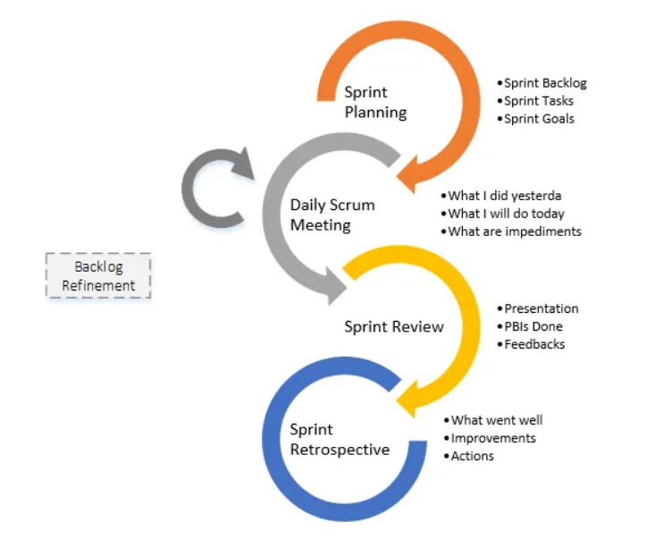
How We Work in a Company Using Agile
1. Sprint Planning – How Work Starts in a Company
How we work:
- At the beginning of the sprint (usually 2 weeks), the Product Owner explains business requirements.
- The development team discusses the tasks and estimates effort.
- The team selects work based on capacity, not pressure.
- A Sprint Goal is finalised.
Company reality:
Management wants fast delivery, but the team commits only to what can be realistically completed.
This avoids last-minute pressure and poor-quality work.
2. Daily Stand-up – How Work Runs Every Day
How we work:
- Every day, the team meets for 10–15 minutes.
- Each member shares:
  - What they completed yesterday
  - What they will do today
  - Any blockers (tool, requirement, dependency)
Company reality:
If a developer is stuck due to access or unclear requirements, it is raised immediately instead of waiting till the deadline.
This saves time, money, and stress.
3. Development Work – During the Sprint
How we work:
- Developers work on assigned user stories.
- Code is written, tested, and reviewed.
- Regular coordination happens with QA and the Product Owner.
- Issues are handled early.
Company reality:
Work is delivered in small, usable parts instead of one big delivery at the end.
4. Sprint Review (Demo) – Showing Work to Stakeholders
How we work:
- Completed features are demonstrated to the Product Owner or client.
- Feedback is taken immediately.
Company reality:
Client sees real progress, not just reports or promises.
5. Retrospective – Improving How We Work
How we work:
- Team discusses:
  - What went well
  - What caused delays
  - What should be improved next sprint
- Action items are created.
Company reality:
Problems in the process are fixed early instead of repeating the same mistakes.

